Exercise 1: Implementing the Singleton Pattern

Step 1 : Create Java Project SingletonPatternExample

Step 2: Define the Singleton Class (Logger.java)

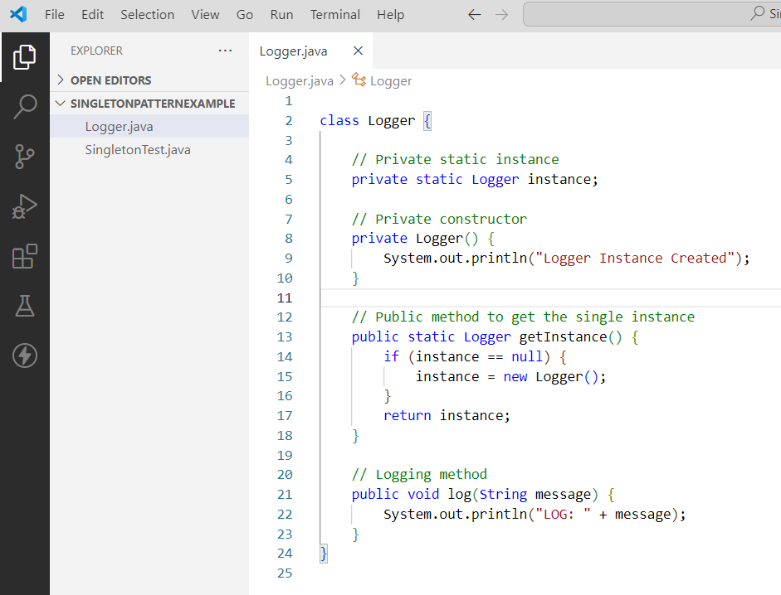

Step 3: Test the Singleton Pattern Using SingletonTest.java

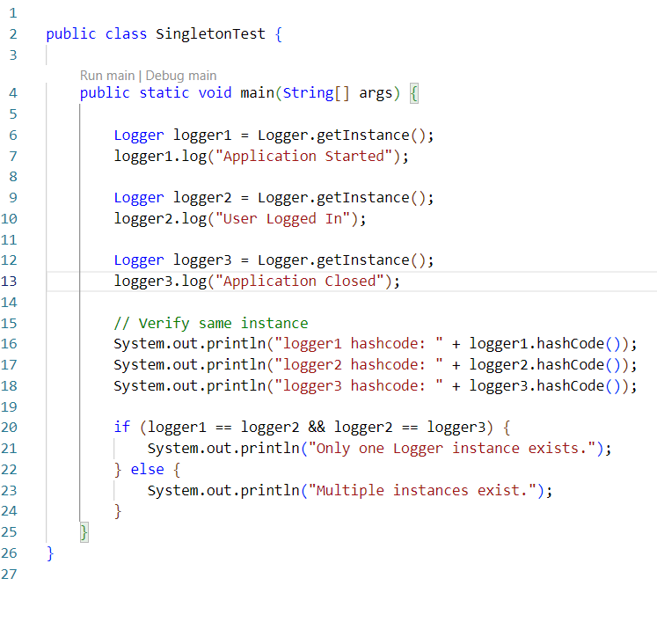

OutPut :


Key Concepts:
- Singleton is a Creational Design Pattern.
- It ensures that only one instance of a class exists.
- It provides a global access point to that instance.
- The class contains a private static instance variable.
- The constructor is private to prevent external object creation.
- A public static getInstance() method is used to access the instance.
- The same object is returned whenever getInstance() is called.
- It helps save memory by avoiding multiple object creations.
- Common use cases include Logger, Database Connection, and Configuration Manager.
- Main advantage: Single shared instance throughout the application.

